32 EuroMed journalists selected for Migration Media Award

* 2ND JULY 2019

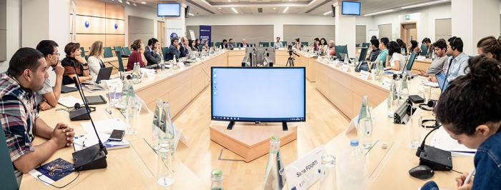

***Mentoring and financial support granted to support evidence based reporting on migration.***

The third edition of the [Migration Media Award](http://www.migration-media-award.eu/index.php/en/)has selected 32 journalists from 12 countries to receive financial and mentoring support to produce stories contributing to a more balanced narrative on migration in the Euro-Mediterranean region.

An international jury, composed of 15 reputable journalists, academics and migration experts, selected the beneficiaries for their journalistic excellence among 89 eligible applications out of 141 entries consisting of previously published pieces and proposals for future productions. This award scheme will reward the selected future productions with financial and mentoring, starting this week in Malta.

The four partners of the Migration Media Award convened top experts and mentors to brief the 32 participants on covering migration and asylum phenomena from July 2 until 4th, 2019. The workshop is being hosted in its headquarters by the [European Asylum Support Office](https://www.easo.europa.eu/) (EASO), with the financial support from the European Union funded programmes EUROMED Migration IV, implemented by the [International Centre for Migration Policy Development](https://www.icmpd.org/our-work/migration-dialogues/euromed-migration-iv/)and the [OPEN Media Hub](http://www.openmediahub.com/) implemented by the Thomson Foundation, and with support from the Malta’s [Ministry for Foreign Affairs and Trade Promotion](https://foreignaffairs.gov.mt/en/Pages/Home.aspx) and the [European Investment Bank (EIB)](https://www.eib.org/en/index.htm).

With continued financial and mentoring support until October 15, 2019, the selected journalists, 16 women and 16 men, will produce their second production, to compete in the six categories of video, print, online, photo, multimedia or radio in the English, French or Arabic languages. A new jury session will select the best stories to receive their Migration Media Awards in December 2019.

The full description of the Migration Media Award can be found at <http://www.migration-media-award.eu/index.php/en/> where all selected entries are available.